January 16, 2023

Dear John:

My co-author and I would like to re-submit our manuscript titled “Implications for Determinacy with Average Inflation Targeting” to Economic Bulletin for publication. The paper is joint work with James Murray (UW – La Crosse). Please find two files attached. The first is the revised manuscript. The second is our point-by-point response to the referees’ comments.

In the paper, we were able to address each point the reviewers raised, hopefully to both their and your satisfaction.

Please do not hesitate to contact me if you have any questions.

Thank you for considering our work, and we look forward to hearing back from you.

Kind regards,

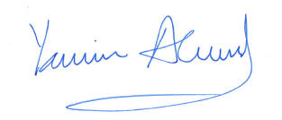

Yamin S. Ahmad

Professor, Dept. of Economics

University of Wisconsin - Whitewater